Geometry: Unit 9, Lesson 10

- What scale factors, $k$, will create an enlarged image?

$$k>1$$

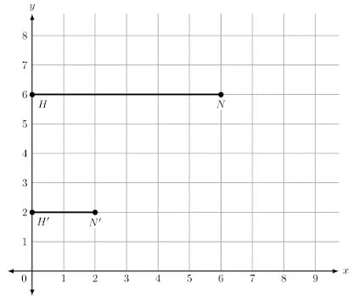
- Segment $\overline{H'N'}$ is formed by applying a dilation of scale factor $k$ onto segment $\overline{HN}$ as shown on the coordinate grid. What is the scale factor of the dilation that maps $\overline{HN}$ onto $\overline{H'N'}$?

$$\frac{1}{3}$$

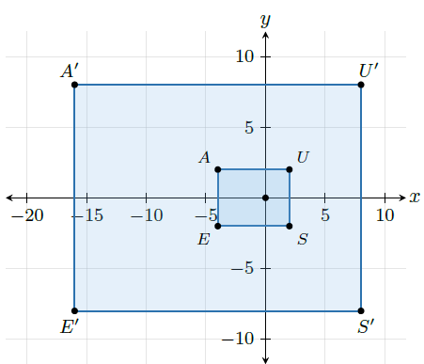
- What is the scale factor of the dilation shown with the given quadrilateral $AUSE$?

$$4$$

